**WEEK – 4(HandsOn)**

**Spring REST using Spring Boot 3**

**2. spring-rest-handson**

**1.Hello World RESTful Web Service :**

package com.cognizant.spring-learn.controller;

import org.slf4j.Logger;

import org.slf4j.LoggerFactory;

import org.springframework.web.bind.annotation.GetMapping;

import org.springframework.web.bind.annotation.RestController;

@RestController

public class HelloController {

private static final Logger LOGGER = LoggerFactory.getLogger(HelloController.class);

@GetMapping("/hello")

public String sayHello() {

LOGGER.info("Start sayHello()");

String message = "Hello World!!";

LOGGER.info("End sayHello()");

return message;

}

}

**OUTPUT:**

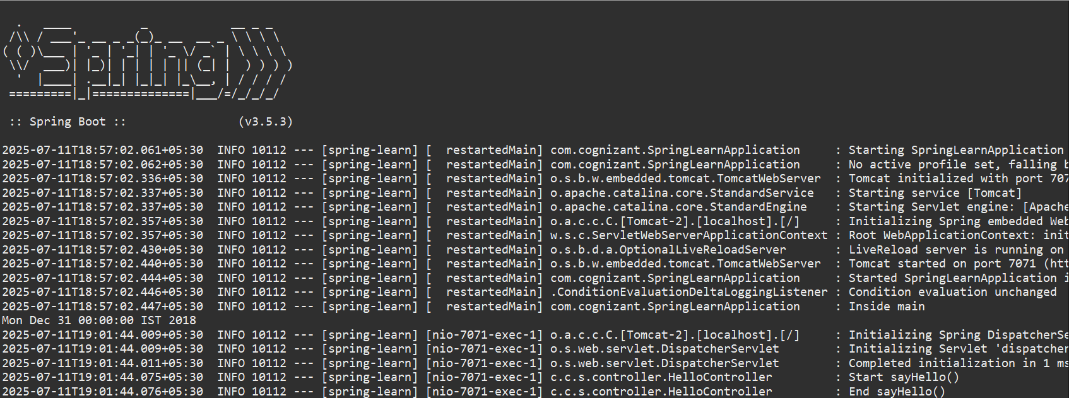

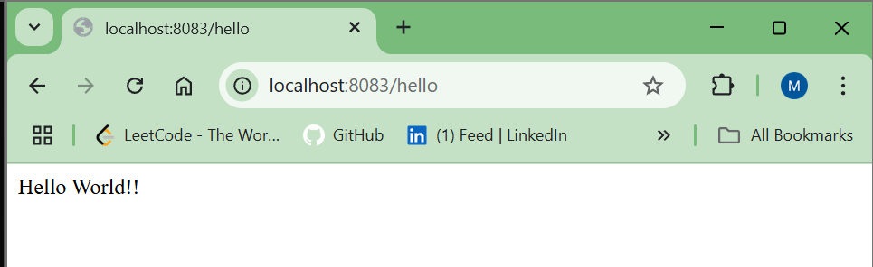

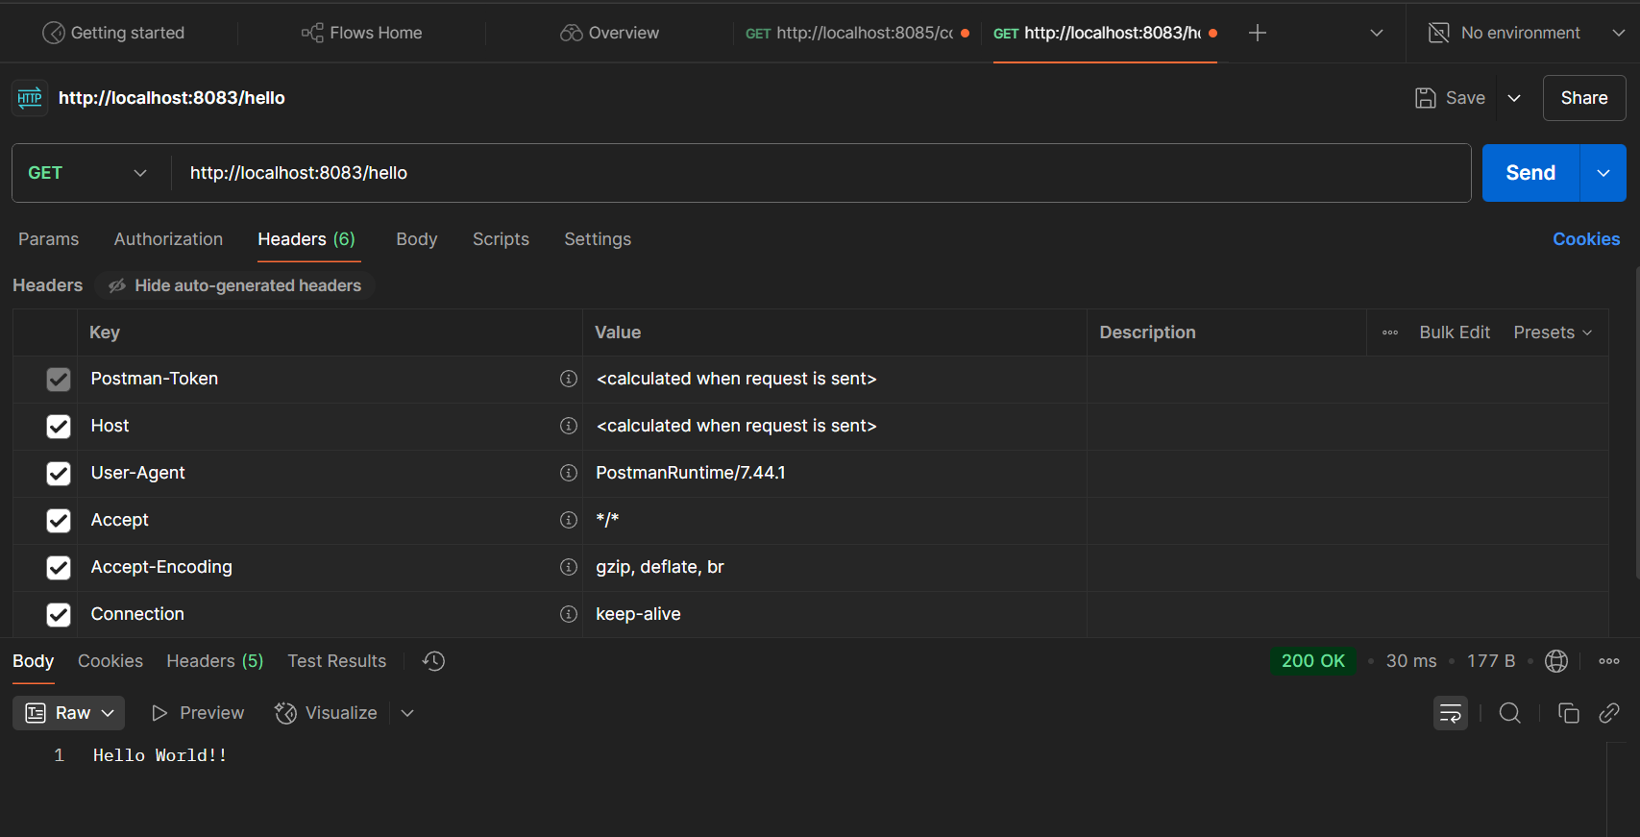

**2. REST - Country Web Service**

<?xml version="1.0" encoding="UTF-8"?>

<beans xmlns="http://www.springframework.org/schema/beans"

xmlns:xsi="http://www.w3.org/2001/XMLSchema-instance"

xsi:schemaLocation="http://www.springframework.org/schema/beans

https://www.springframework.org/schema/beans/spring-beans.xsd">

<bean id="in" class="com.cognizant.springlearn.model.Country">

<property name="code" value="IN"/>

<property name="name" value="India"/>

</bean>

</beans>

package com.cognizant.springlearn.model;

public class Country {

private String code;

private String name;

public Country() {

}

public Country(String code, String name) {

this.code = code;

this.name = name;

}

public String getCode() {

return code;

}

public void setCode(String code) {

this.code = code;

}

public String getName() {

return name;

}

public void setName(String name) {

this.name = name;

}

}

package com.cognizant.springlearn.controller;

import com.cognizant.springlearn.model.Country;

import org.slf4j.Logger;

import org.slf4j.LoggerFactory;

import org.springframework.context.ApplicationContext;

import org.springframework.context.support.ClassPathXmlApplicationContext;

import org.springframework.web.bind.annotation.RequestMapping;

import org.springframework.web.bind.annotation.RestController;

@RestController

public class CountryController {

private static final Logger LOGGER = LoggerFactory.getLogger(CountryController.class);

@RequestMapping("/country")

public Country getCountryIndia() {

LOGGER.info("Start getCountryIndia()");

ApplicationContext context = new ClassPathXmlApplicationContext("country.xml");

Country country = context.getBean("in", Country.class);

LOGGER.info("End getCountryIndia()");

return country;

}

}

**OUTPUT:**

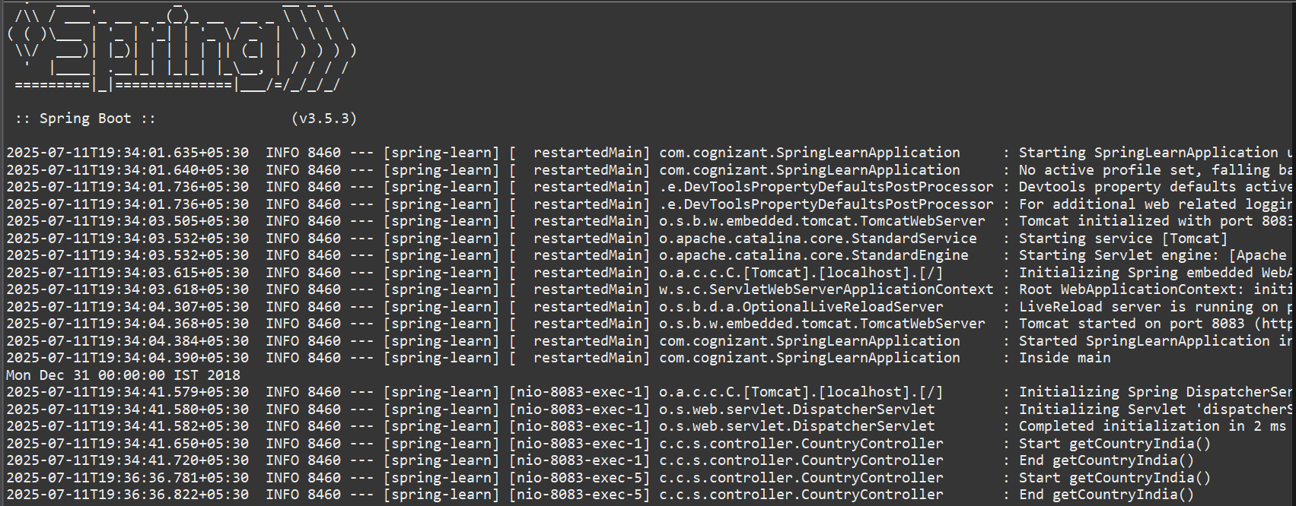

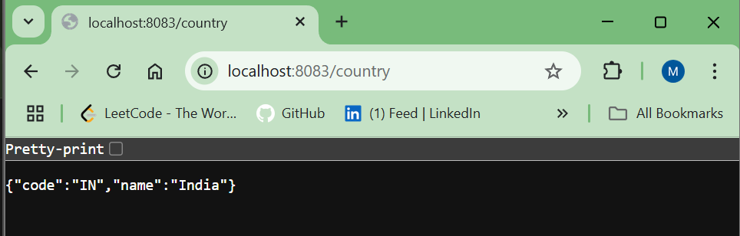

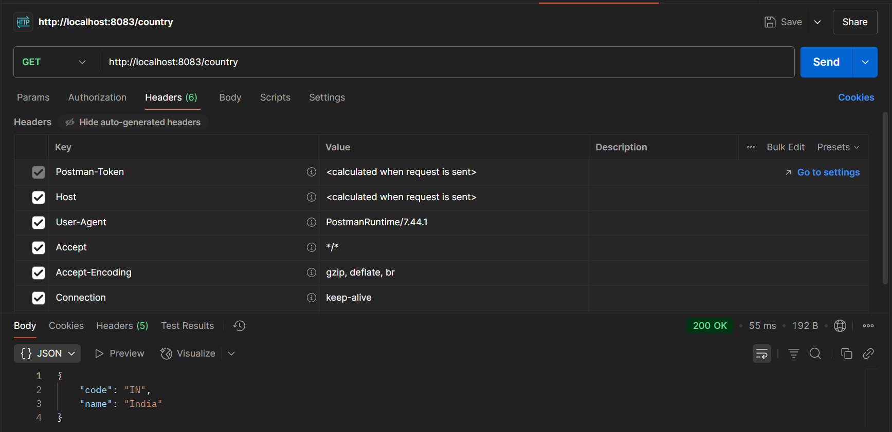

**3. REST - Get country based on country code**

<?xml version="1.0" encoding="UTF-8"?>

<beans xmlns="http://www.springframework.org/schema/beans"

xmlns:xsi="http://www.w3.org/2001/XMLSchema-instance"

xsi:schemaLocation="http://www.springframework.org/schema/beans

https://www.springframework.org/schema/beans/spring-beans.xsd">

<bean id="in" class="com.cognizant.springlearn.model.Country">

<property name="code" value="IN"/>

<property name="name" value="India"/>

</bean>

<bean id="us" class="com.cognizant.springlearn.model.Country">

<property name="code" value="US"/>

<property name="name" value="United States"/>

</bean>

<bean id="countryList" class="java.util.ArrayList">

<constructor-arg>

<list>

<ref bean="in"/>

<ref bean="us"/>

</list>

</constructor-arg>

</bean>

</beans>

package com.cognizant.springlearn.model;

public class Country {

private String code;

private String name;

// Getters and Setters

public String getCode() {

return code;

}

public void setCode(String code) {

this.code = code;

}

public String getName() {

return name;

}

public void setName(String name) {

this.name = name;

}

}

package com.cognizant.springlearn.service;

import com.cognizant.springlearn.model.Country;

import org.springframework.context.ApplicationContext;

import org.springframework.context.support.ClassPathXmlApplicationContext;

import org.springframework.stereotype.Service;

import java.util.List;

@Service

public class CountryService {

public Country getCountry(String code) {

ApplicationContext context = new ClassPathXmlApplicationContext("country.xml");

List<Country> countryList = context.getBean("countryList", List.class);

return countryList.stream()

.filter(c -> c.getCode().equalsIgnoreCase(code))

.findFirst()

.orElse(null);

}

}

package com.cognizant.springlearn.controller;

import com.cognizant.springlearn.model.Country;

import com.cognizant.springlearn.service.CountryService;

import org.slf4j.Logger;

import org.slf4j.LoggerFactory;

import org.springframework.beans.factory.annotation.Autowired;

import org.springframework.web.bind.annotation.*;

@RestController

public class CountryController {

private static final Logger LOGGER = LoggerFactory.getLogger(CountryController.class);

@Autowired

private CountryService countryService;

@GetMapping("/countries/{code}")

public Country getCountry(@PathVariable String code) {

LOGGER.info("Start getCountry()");

Country country = countryService.getCountry(code);

LOGGER.info("End getCountry()");

return country;

}

}

**OUTPUT:**

